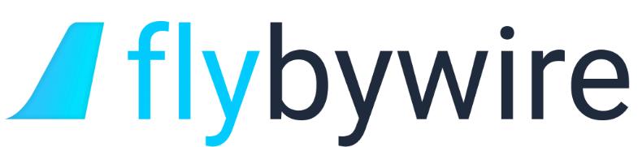

**Terms of Services**

Revision 2

**Terms of Services Amendment History**

|  |  |  |
| --- | --- | --- |
| **Revision** | **Effective Date** | **Notes** |
| 1 | 21/12/2020 | First Release  Credits to @nathaninnes (Sabes) |
| 2 | 03/12/2021 | Branding adjustments  Credits to @inaxair (Inax) |
|  |  |  |

*All dates are formatted in DD/MM/YYYY.*

1. **Minimum Age Requirement**

To protect the privacy of younger people it is very important that we implement an age restriction of **13 and over** to join Flybywire Simulation services such as this website and Discord or any other communication platform, other platforms may be subject to their own conditions. By using Flybywire Simulations services, you agree that you are 13 years of age and the minimum age of digital consent in your country.

Flybywire Simulations reserve the right to remove users under the age of 13 and minimum age of digital consent in any given case from communication platforms.

1. **User Complaint**

In the event of a user should feel the need to make a complaint against another member, with regards to violating our **Terms of Service** or **Communication Platform Rules (Discord)**, they can contact the Moderation team through Discord private message.

When writing the report please state the members name and what they are violating. All complaints will be dealt with as professionally and as quickly as possible.

1. **Legal Requirements**

All users of FlyByWire Simulations who choose to fly our add-on must own a **legal** copy of Microsoft Flight Simulator (MSFS)